Literature and Culture Forum Guidelines

As stated in the syllabus, part of your class participation grade will come from your posting regular responses to the assigned readings. There are a couple reasons why I am asking you to do this. At a minimum level, it is one way to help you stay on schedule with the readings, and I believe it is a richer way to do so than to give you pop quizzes in class. On a more profound level, this is a way for you to engage more deeply with the readings. Writing—even informal writing—is a form of thinking: we frequently don’t know what we think about something until we reflect on it in writing. Finally, these responses become a record of our thoughts as a class and can become a written “conversation” that enriches the discussions we have during class sessions. Your posts, or entries, will follow the form defined below.

Responses to my Prompts (approximately 150 words)
Prior to each class session, I will post a prompt that relates to the assigned readings. You will answer these prompts in a brief paragraph. A high-quality answer will go beyond a perfunctory, two-sentence answer and will demonstrate serious reflection on the text we are reading. I will frequently ask these same questions in class, so the fact that you have a chance to think about them before class should help you feel more confident participating in class discussions. The main criterion for a comment is that it must be something that someone else could reasonably respond to--in other words, simply summarizing the reading would not be a sufficient comment.

Submission Requirements
You will post somewhere around 40 responses over the course of the semester. This is a lot, and I know it, but I also know that, in a course where reading and discussion are the main activities, you will only have a satisfying experience if you actually read and think about the material: being a casual and passive observer won’t work for you in this course. So the rhythm will be that—unless otherwise notified—you have a prompt to respond to before each class session for which there is a reading assignment. On most weeks, you will have three such responses due. My suggestion is that you complete your paragraph immediately upon completing the reading assignment, while the text is still fresh in your head.

Because this is a fairly rigorous requirement, I am not requiring that you respond to other students’ responses as part of your grade. My hope is that you may find some discussions interesting enough in their own right that you want to post more than the minimum.

Absence Policy and Late Forum Posts
Because entries can be posted at any time and from virtually any location, absence from class is not normally a justifiable excuse for not participating in the discussion forum. Should you find yourself in circumstances that prevent you from posting to the forum, I expect you to communicate this to me promptly so that we can address the issue. Reading responses that are posted after the related class session has begun are considered late; late posts, even good posts, will not receive full credit.

Grading Standards
Your participation in the discussion forum will be measured both quantitatively and qualitatively. I will use the following criteria in this assessment:

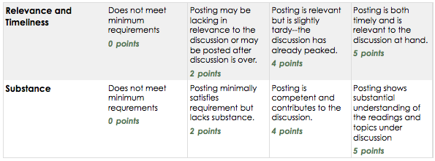

Discussion posts are primarily for your benefit, to help you keep up with assigned readings, to help you retain what you read by thinking further about the assignments, to help you remember key points for tests, and to give you material you can contribute during class discussions. I expect them to be substantial in the sense that they are focused on the readings and offer some support for whatever opinions are expressed.

